USING OSLIS (THE OREGON SCHOOL LIBRARY INFORMATION SYSTEM)

Go to https://oslis.org/
(At home, your username is “port” and your password is “oslis”)

- Click on “Secondary Student:2.

- Click on “Find Information, ” the middle box

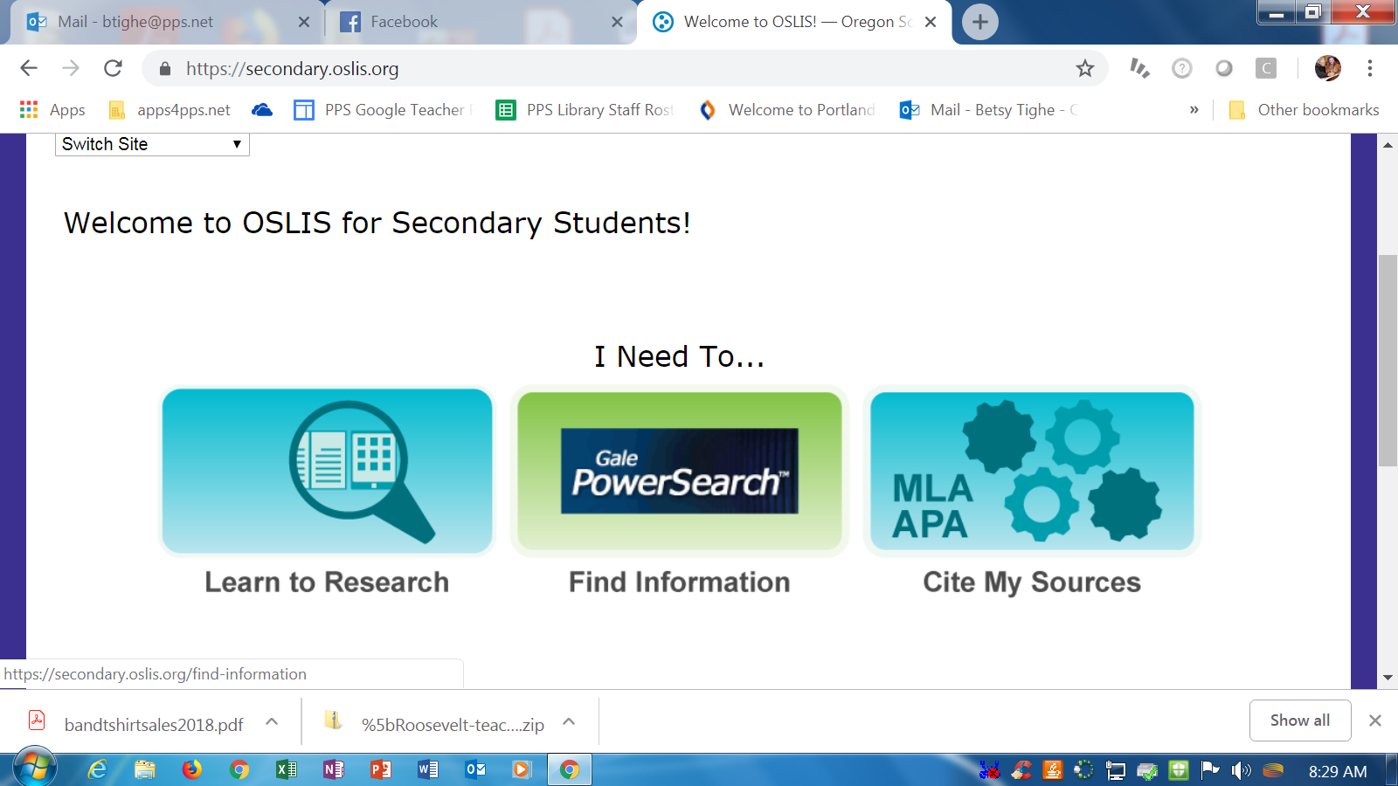

- Choose the most appropriate database to your subject. Like Student Resources in Context for broader topics or LitFinder for literature specific info.

- or Click on “All Gale Databases/Gale Powersearch.” (Third row down on right) to see what your choice is. If you are doing a food subject, for instance, you might want to use the Agriculture and Culinary Arts Collections.
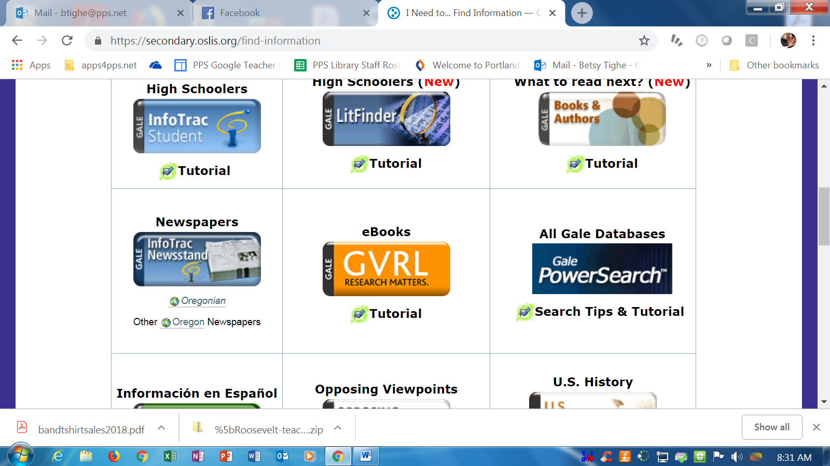

- Deselect all the databases, then select the ones you want.
Put your search term in the search bar and hit enter.

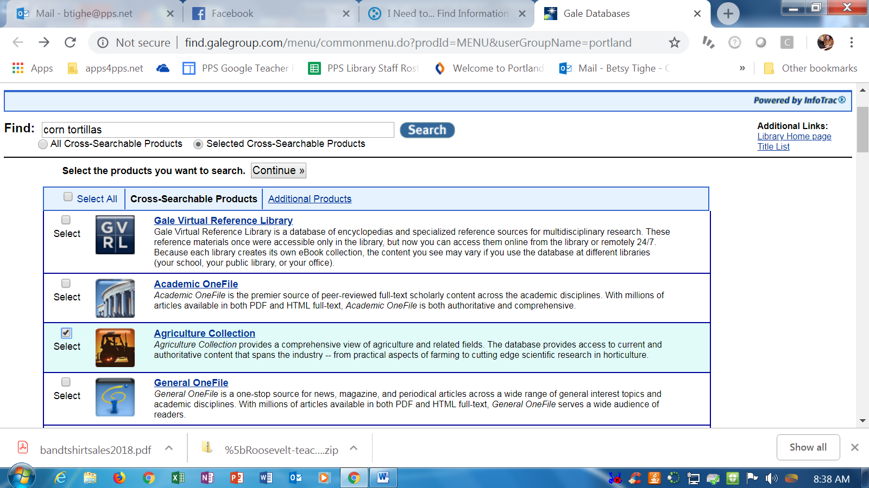

You will see results in the tabs across the upper right hand side: Magazines, Academic Journals, Books, News.

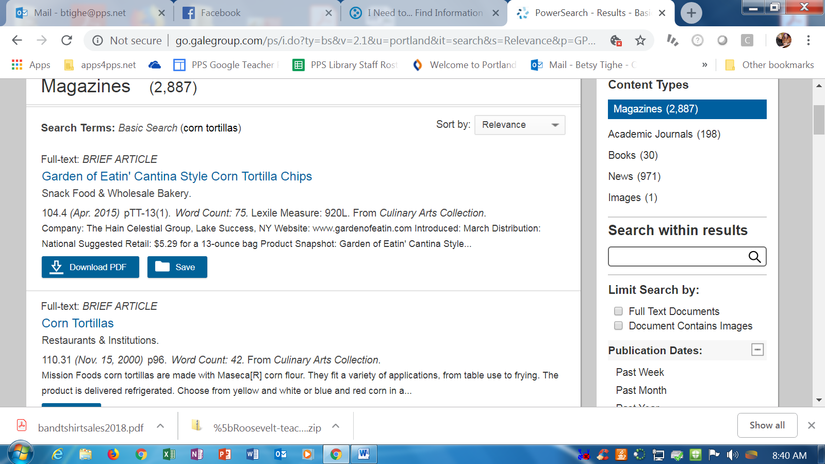

You can see that it is always better to be more specific in your search. Here I added “history of,” and you can see it drops my results way down.

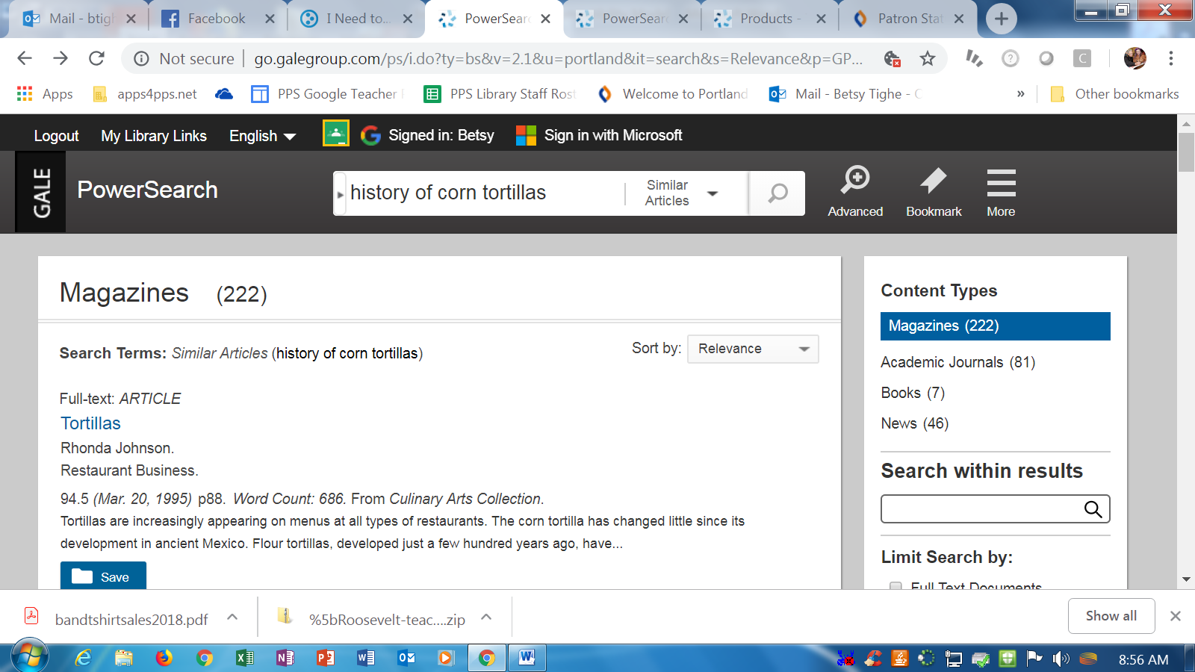

If you select “articles” then go to one article, you have a variety of tools. I made a folder. You can also listen to the article, email the article to yourself or your teacher, and there are built in citation tools.



